**AT PROJECT REPORT**

**BTECH IT SIXTH SEMESTER**

**ATTENDANCE TRACKER**

A PROJECT REPORT

***submitted by***

|  |  |  |
| --- | --- | --- |
| **Name** | **Registration Number** | **Roll Number** |
| JAY VEER SINGH | 180911206 | 31 |
| ADITYA AAYUSH | 180911220 | 32 |
| ARJUN PRAVEEN | 180911230 | 33 |



**CONTENTS**

**PAGE NO.**

**ABSTRACT**  **3**

**LIST OF ABBREVIATIONS**  **3**

**INTRODUCTION**  **3**

**LANGUAGE DESCRIPTION**    **4**

**DATABASE DESCRIPTION 5**

**PROJECT DESCRIPTION 6**

**PROJECT FUNCTIONS 6**

**DESIGN 7**

**UI SCREENSHOTS 8**

**RESULT,CONCLUSION 11**

**FUTURE WORK 12**

**REFERENCES 14**

**ABSTRACT**

The Administrator will add users as a student or a faculty, will have the capability to modify the user database and attendance record. Each user will be able to login with their credentials to give and take the attendance. Student’s biometrics and location will be verified before attendance is recorded successfully. Faculties are responsible for initiating the attendance taking process and will be able to view the details of every student in a class. Students will be able to view their attendance of each enrolled course on a daily basis. Any modifications to be made can be handled by the faculty initiating the attendance process or the administrator.

**LIST OF ABBREVIATIONS**

**Report**                               an account of items

**Database**                           collection of information in a structured form

**adminID**                           unique id for admin

**regno** registration

**INTRODUCTION**

Attendance is very important for every organization. It can decide whether an organization such as educational institutions will be successful in the future. Taking attendance can be time consuming and manual process is prone to error while recording presence. To make the process of taking attendance simpler we are implementing the self-use of smartphones. This software is designed for daily attendance of students in an institute. Besides validating and recording presence of a student in class, it also facilitates to access and maintain attendance information.

**LANGUAGE DESCRIPTION**

The project was done using Java programming language. It is a high-level, class-based, object-oriented programming language that is designed to have as few implementation dependencies as possible. Java code can run on all platforms that support Java without the need for recompilation. Java applications are typically compiled to bytecode that can run on any Java virtual machine (JVM) regardless of the underlying computer architecture. Java is the primary option for developing native applications on the Android platform. It manages to fuse the powerful features of the classic C and C++ programming languages, while also managing to eliminate many of the drawbacks of the two. Not only is Java easy to learn and understand, but it’s also structured to be platform-independent and secure.

Besides Java, we use XML for designing our layouts because XML is lightweight language, so it doesn’t make our layout heavy.Extensible Markup Language (XML) is a markup language that defines a set of rules for encoding documents in a format that is both human-readable and machine-readable.

**DATABASE/BACKEND DESCRIPTION**

The backend has been hosted on Firebase and makes use of Firebase Realtime Database & Firebase Storage. Firebase Realtime Database is a real-time NoSQL Cloud database that stores data as a JSON object. Since it is Firebase is a NoSql database, it allows flexible schemas in the form of multiple key value pairs for attributes. Our database consists of 3 main objects : Administrator, Student, Course. Administrator has admin rights and can access all student and faculty details. Administrator can also add new student registrations. Student can view his current courses and detailed attendance report for each course. The course object is used to store course id and course names, which can be referenced in other objects such as courses selected by a student. This helps reduce redundancy in the student table as course name will not be stored in multiple course instances in the student's object.

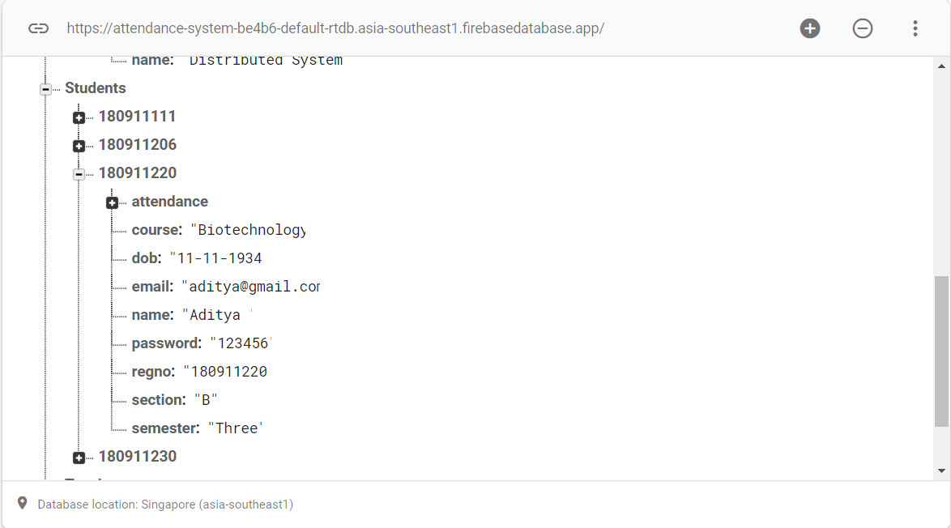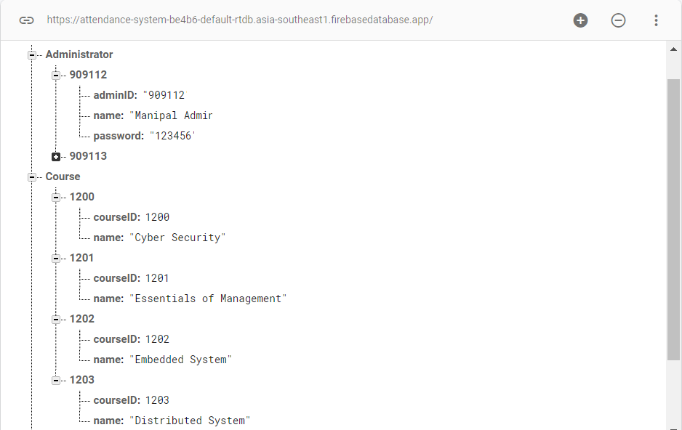

**PROJECT DESCRIPTION**

This application is mainly designed for the faculties and other staff members of the organization who maintain attendance and marks regularly. Using this system, the subject handlers, staffs or the authorities can verify the number of students present or absent in the class meeting sessions.

This application allows the users to mark attendance through mobile devices and to keep in touch with students. Furthermore, this application allows the teachers to mark and edit the attendance and to add the marks in the system database for further retrieval. this system will also help in evaluating attendance eligibility criteria of a student.

**PRODUCT FUNCTIONS.**

**Login**: Student or administrator can login by entering their username and password and choosing their appropriate category in the spinner. The details are validated against the details existing in the database.

**View Profile**:  After logging in both the student and the administrator can view their respective profiles retrieved from the database.

**View Students** (Admin): Admin can navigate to the students fragment and view all registered students, courses and their corresponding attendance.

**Search Students** (Admin): Admin can search for students in the students fragment by name or registration number.

**View Faculty** (Admin): Admin can view all faculty details and their respective courses.  
**Register Student** (Admin): Admin can register new student.

**View Courses** (Student): Student can view registered courses.

**View Attendance** (Student): Student can view detailed attendance of each course in the attendance fragment.

**Update Attendance** (Student): Student can update attendance for that day in attendance fragment.

**DESIGN**

**Usecase Diagram**

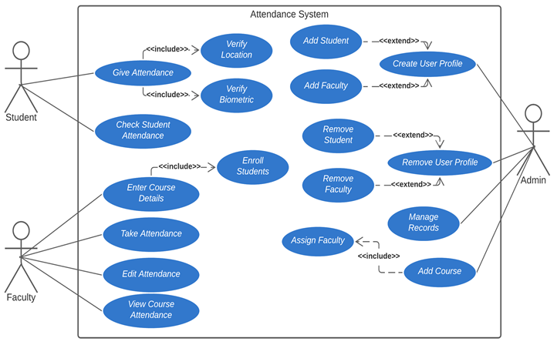

**Activity Diagram**

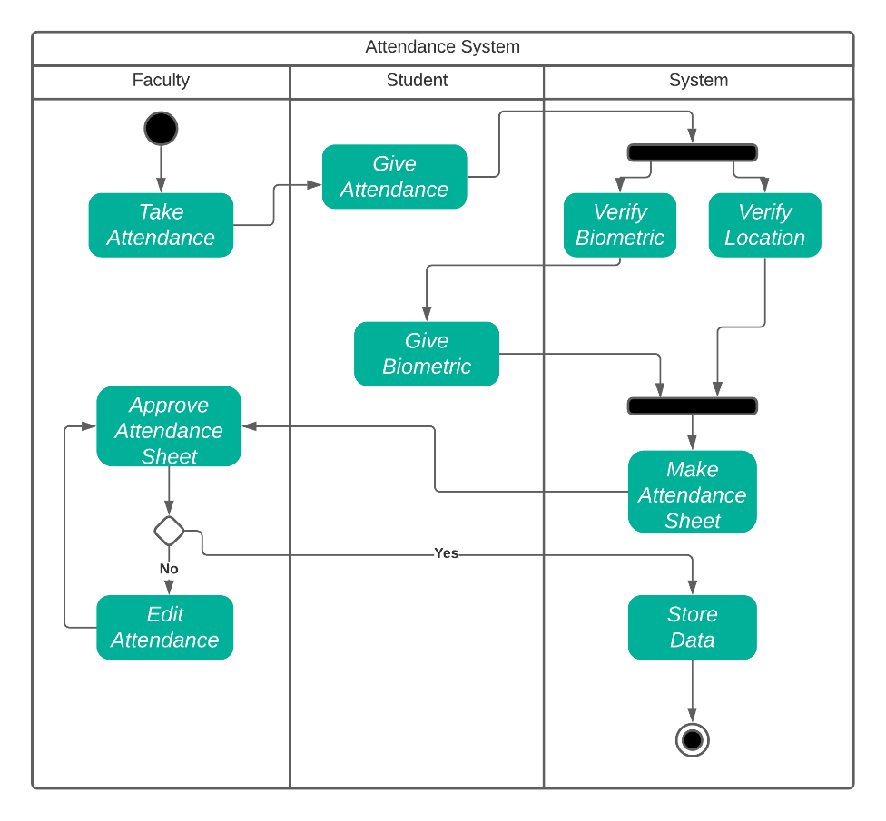

**UI SCREENSHOTS**

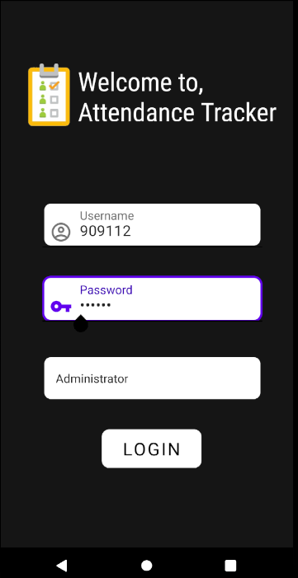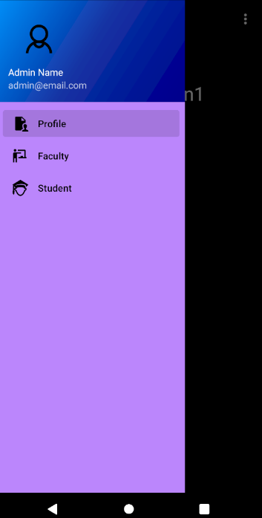

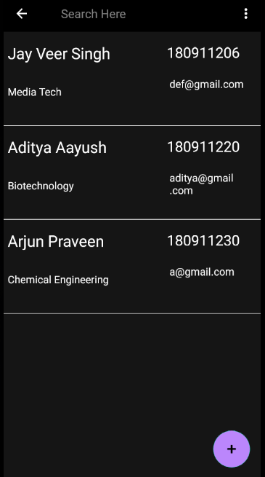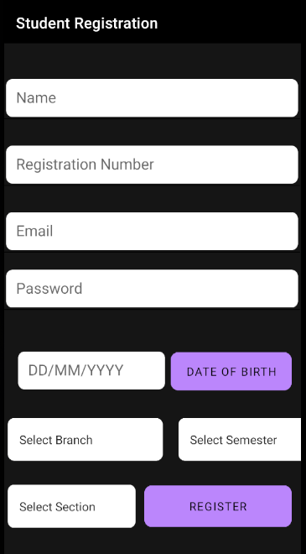

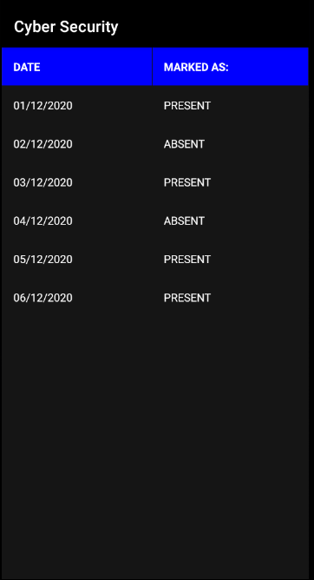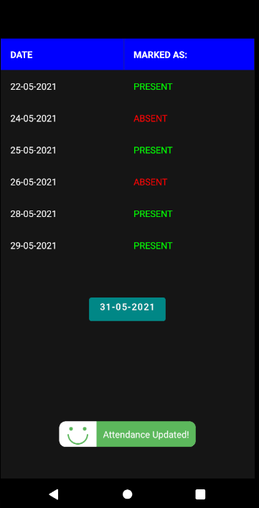

**RESULTS**

Video with voiceover: <https://youtu.be/SAhibyDOS9Y>

**Backend :** Implemented Realtime Database using Firebase by Google, which reflects changes in the database onto the application it is connected with as they happen. It is an NoSQL DBMS which stores unstructured data as key value pairs.

**Frontend :** Used Material Design and Android Jetpack libraries from “androidx” components for implementing UI. Used components like Floating Action Button, Toolbar, App Bar Navigation UI and Navigation Drawer to make the app responsive and aesthetically pleasing.

**Administrator User:** Adds and deletes Faculty and Student users, can view Student attendance, enrolled courses, and all user’s details.

**Student User:** Can view enrolled courses, attendance. Can give attendance for current day. Attendance reflects into database as key value pair of date and attendance status of student.

**CONCLUSION**

This application provides educational institutions with a simple and elegant solution to replace the age-old paper pen attendance system. It is very beneficial and time saving especially when the number of students is large. This attendance system is superior to biometric system as the latter requires lot of hardware investment. There is lot of scope for this project as it has the potential to integrate many spheres of technology(blockchain for instance).

**FUTURE WORK**

**Faculty User**

* The faculty user would oversee several courses and student’s attendance regarding those courses.
* Faculty User initiates the attendance taking process that enables the attendance button for the Student User.
* Faculty User can view the attendance for all students in their own courses.
* Faculty User would be able to edit attendance records of students in their courses or schedule course time table

**Attendance Verification**

* We need to implement various methods to ensure the validity of attendance record from student.
* Firstly we ensure Student User is in the correct location:
  + - Geofencing could be implemented to ensure student cannot misuse the attendance functionality of the app.
    - Student needs to be in the classroom that the lecture is taking place in
    - We could get network information and ensure that both Student and Faculty users are connected to same local network i.e. the lecture hall
    - Alternatively, we could store locations of specific Lecture Halls and add them to the database. The faculty assigns lecture hall to a lecture, and student location must be within the radius defined as lecture hall
* We can verify that the Student User in the one handling the device by using the inbuilt fingerprint scanner.

**REFERENCES**

[1] https://developer.android.com/guide/topics/ui/look-and-feel

[2] https://firebase.google.com/docs